**A Database Mini Project Report**

**on**

**“College Hostel Management System”**

Submitted to the

Savitribai Phule Pune University

In partial fulfillment for the award of the Degree of

Bachelor of Engineering

in Information Technology

Presented By

TE-9

**Yash Jeswani (33123)**

**Kunal Sachdev (33130)**

**Soham Kotalwar (33125)**

**Animesh Landge (33131)**

Under the guidance of

**Prof. Sumitra Jakhete**



Department Of Information Technology

Pune Institute of Computer Technology College of Engineering

Sr. No 27, Pune-Satara Road, Dhankawadi, Pune - 411 043.

**2019-2020**



**CERTIFICATE**

This is to certify that the mini project report entitled **“College Hostel Management System”** being submitted by **Yash Jeswani (33123)** , **Kunal Sachdev (33130)** **, Soham Kotalwar (33125) , Animesh Landge (33131)** from TE-9 is a record of bonafide work carried out by him/her under the supervision and guidance of **Prof. Sumitra Jakhete** in partial fulfillment of the requirement for **TE (Information Technology Engineering) – 2015 course** of Savitribai Phule Pune University, Pune in the academic year 2019-2020.

Date: 16/10/2019

Place: Pune

Guide Subject Coordinator Head of the Department

Principal

This Project Based Seminar report has been examined by us as per the Savitribai Phule Pune University, Pune requirements at **Pune Institute of Computer Technology, Pune – 411043** on **16/10/2019**

Internal Examiner External Examiner

**ACKNOWLEDGEMENT**

I would like to express my special thanks of gratitude to my teacher (Sumitra Jakhete) As well as our Head of department (Anant Bagade) who

gave me the golden Opportunity to do this wonderful project on the Topic

(College Hostel Management System),which also helped me in doing a lot of Research and i came to know about so many new things I am really thankful to them.

Secondly I would also like to thank my Senior Colleagues and friends who helped me a lot in finalizing this project within the limited time frame.

I would Like To appreciate my Team Members Who Individually Worked A lot

And Successfully Completed Our Mini-Project.

I would like to Acknowledge Mr Jagdish Kamble for sharing their truthful and illuminating views on a number of issues related to the project. Resources that we have used for completing our project stackoverflow, tutorialspoint, javapoint ,we are glad to get advice from seniors and lab teacher.

Thankyou.

Yash Jeswani

Kunal Sachdev

Soham Kotalwar

Animesh landge

(Students Name & Signature)

**CONTENTS**

|  |  |  |
| --- | --- | --- |
| **Sr. No.** | **TITLE** | **Page no** |
| **1.** | **Content’s Abstract** | **5** |
| **2.** | **Introduction** | **5** |
| **3.** | **Overview** | **6** |
| **4.** | **Background and Motivation** | **7** |
| **5.** | **Methodology** | **7** |
| **6.** | **Scope** | **8** |
| **7.** | **Requirements** | **8** |
| **8.** | **E-R Diagram** | **9** |
| **9.** | **Schema Diagram** | **10** |
| **10.** | **Relational Database Design** | **10** |
| **11.** | **Database Normalization** | **14** |
| **12.** | **Graphical User Interface** | **17** |
| **13.** | **Conclusion** | **28** |
| **14** | **References** | **28** |

***1.ABSTRACT***

In this project we are created one application which is easy to access user friendly. For this application we used the backend as Mysql DB to store the data which is used in the application and for the user interface we had used the Jsp and HTML. Two kinds of people are able to use this application as warden and the student as well. The warden is able to add student very easily, add leave, late details and by seeing the payment log .The warden is the only person who is able to add and remove the student from the hostel and take attendance daily.

***2. INTRODUCTION***

**2.1       Background**

 This Hostel Management System is developed in favor of the hostel management team which helps them to save the records of the students about their rooms and other things. It helps them from the manual work from which it is very difficult to find the record of the students and the information about those ones who had left the hostel years before.

This solution is developed on the plight of the hostel management team, through this they cannot require so efficient person to handle and manage the affairs of the students in the hostel, all you need to do is to login as administrator and you can see the information of all the students who have obtained and registered their hostel form, click verify to ascertain their eligibility and allocate them to the available hostel.

Identification of the problems of the existing hostel management leads to the development of computerized solution that will be compatible to the existing hostel management with the solution which is more users friendly and more GUI oriented. We can improve the efficiency of the hostel management, thus overcome the drawbacks of the existing management.

**2.2       Objectives**

The main objectives of this project work are that:

* Student will no longer apply for their hostels manually.
* The warden can see and access the student’s data.
* This also will reduce the manual work of the persons in admin penal.
* It helps the admin to know the number of students that can leave in a room and a block.
* To ensure that the number of student staying in a room does not exceed specified limit.
* Help the admin to disseminate information to students without calling for a meeting.
* To know the number of items (e.g. bed) given to student staying in the hostel

The system helps the admin to:

* Allot different students to their different rooms.
* Vacate the student from the hostels
* Control the status of the hostel fee payment.
* Edit the details of the students and modify the students records.
* Generating payment report.

***3.* *OVERVIEW***

This report discusses the result of the work done in development of "College Hostel Management System ” on “JSP” Front-end Platform and “MySQL” as back-end Platform.

At the development of an application JSP provides a good connecting facility between all pages, also the back-end MySQL is most important to save all the data related the application and servlet used for connecting purpose with mysql database and jsp page and passing information from servlet to jsp page and vice-versa.

***4.BACKGTROUND AND MOTIVATION***

The definition of our problem lies in manual system and a fully automated system.

**Manual system:** The system is very time consuming and lazy. This system is more prone to errors and sometimes the approaches to various problems are unstructured. There exists too much paperwork in this system and hence it is difficult to effectively manage and use the data.

**Technical system:** The new system focuses on completely cutting down on maintaining paperwork. The entire data is present digitally and is effectively managed from a single machine. Moreover, there is no need to review data to send notifications to the concerned people as the system itself detects whether there is a need to inform the concerned people.

***5. METHODOLOGY***

To implement the above goals, the following methodology needs to be followed:

1.Hardware Requirements:-

* Processor :- 1.6GHz
* RAM: 1 GB
* Hard Disk: 4 GB Space Requirement

2.Software Requirements:-

* Mysql server, tomcat server
* Eclipse JEE
* Browser:- Mozilla firefox , Internet Explorer

3.Languages:- HTML,CSS,BOOTSTRAP,JS,JSP,SERVLET

***6.SCOPE OF PROJECT***

The scope of the project is clear to give a simple and attractive application to simplify the work as well as to reduce the efforts while doing it offline or we can say by doing it with old methods.

In this application we are able to save database of all students present in the hostel and we can add, remove students , add leave, late details of the students, marking attendance everyday , generating report the payment log details. Also If any student is absent without taking leave then mail will be sent to their respective gaurdian, student records can be added by uploading csv file successfully.

***7.REQUIRMENTS***

We are going to perform the project on windows platform so we need the os as windows. Any version of windows as windows xp, windows 7or windows 8.The system should have minimum ram of 256MB as well as minimum storage capacity of 15GB.The system should contain the server software named as “Tomcat” .And mysql DB of version 5.6.3 or above. First we have to install both software and we have to do connectivity between them by changing the configuration file of “tomcat”.

***8.E-R DIAGRAM***

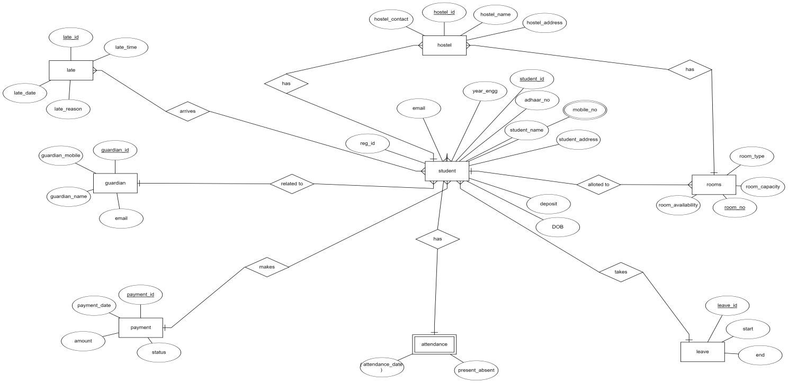

***9.SCHEMA DAIGRAM***

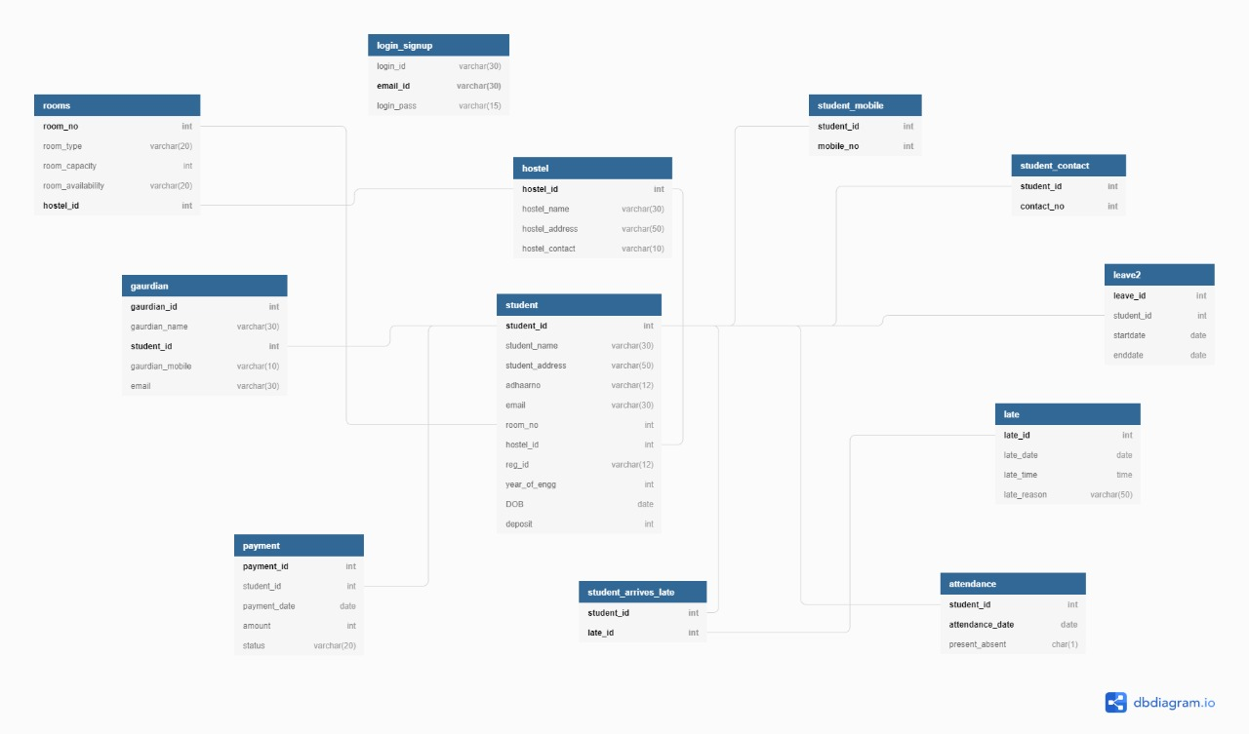

***10. RELATIONAL DATA BASE DESIGN***

**1] Login :-**

login_id, email_id, password

|  |  |  |
| --- | --- | --- |
| login_id | email_id(PK) | password |

**2] Student :-**

student_id, student_name, student_address, aadharNo, email, room_no, hostel_id, reg_id, year_of_engg, DOB, deposit

|  |  |  |  |  |  |  |  |  |  |  |
| --- | --- | --- | --- | --- | --- | --- | --- | --- | --- | --- |
| student_id  (PK) | student_name | student_address | aadharNo | email | room_no  (FK) | hostel_id  (FK) | reg_id | year_of_engg | DOB | deposit |

**3]student_mobile :-**

student_id, mobile_no

primary key(student_id,mobile_no)

|  |  |
| --- | --- |
| student_id(FK) | mobile_no |

**4]guardian :-**

guardian_id, student_id, guardian_name, guardian_email, guardian_mobile

primary key(student_id,guardian_id)

|  |  |  |  |  |
| --- | --- | --- | --- | --- |
| guardian_id | student_id(FK) | guardian_name | guardian_email | guardian_mobile |

**5]payment :-**

payment_id, student_id, payment_date, amount, status

|  |  |  |  |  |
| --- | --- | --- | --- | --- |
| payment_id(PK) | student_id(FK) | payment_date | amount | status |

**6]hostel :-**

hostel_id, hostel_name, hostel_address, hostel_contact

|  |  |  |  |
| --- | --- | --- | --- |
| hostel_id(PK) | hostel_name | hostel_address | hostel_contact |

**7]rooms :-**

room_no, room_type, room_capacity, room_availability, hostel_id

primary key(room_no,hostel_id)

|  |  |  |  |  |
| --- | --- | --- | --- | --- |
| room_no | room_type | room_capacity | room_availability | hostel_id(FK) |

**8] leave :-**

leave_id, student_id, start_date, end_date

|  |  |  |  |
| --- | --- | --- | --- |
| leave_id(PK) | student_id(FK) | start_date | end_date |

**9] attendance :-**

 student_id, attendance_date, present_absent

primary key(student_id,attendance_date)

|  |  |  |
| --- | --- | --- |
| student_id(FK) | attendance_date | present_absent |

**10] late :-**

late_id, late_date, late_time, late_reason

|  |  |  |  |
| --- | --- | --- | --- |
| late_id(PK) | late_date | late_time | late_reason |

**11] student_arrives_late :-**

student_id, late_id

primary key(student_id,late_id)

|  |  |
| --- | --- |
| student_id(FK) | late_id(FK) |

***11. Database Normalization:***

**First Normal Form:-**

The relation is in 1NF if it has no repeating groups. All  tables has no repeating groups so they are in 1NF.

**Eg:-**

**Student :-**

student_id, student_name, student_address, aadharNo, email, room_no, hostel_id, reg_id, year_of_engg, DOB, deposit

|  |  |  |  |  |  |  |  |  |  |  |
| --- | --- | --- | --- | --- | --- | --- | --- | --- | --- | --- |
| student_id  (PK) | student_name | student_address | aadharNo | email | room_no  (FK) | hostel_id  (FK) | reg_id | year_of_engg | DOB | deposit |

**Second Normal Form:-**

A relation is said to be in second normal form if it is already in first normal form and it has no partial dependency.

**1)**    **Login:**

The absence of partial dependency in relation takes it into 2NF without any modification

**2)**    **Student:**

The absence of partial dependency in relation takes it into 2NF without any modification.

**3)**   **student_mobile:**

The absence of partial dependency in relation takes it into 2NF without any modification.

**4)**    **guardian :**

The absence of partial dependency in relation takes it into 2NF without any modification.

**5)**    **payment :**

The absence of partial dependency in relation takes it into 2NF without any modification.

**6)**    **hostel :**

The absence of partial dependency in relation takes it into 2NF without any modification.

**7)**    **rooms :**

The absence of partial dependency in relation takes it into 2NF without any modification.

**8)**    **leave :**

The absence of partial dependency in relation takes it into 2NF without any modification.

**9)**    **attendance :**

The absence of partial dependency in relation takes it into 2NF without any modification.

**10)**    **late :**

The absence of partial dependency in relation takes it into 2NF without any modification.

**11)**    **student_arrives_late :**

The absence of partial dependency in relation takes it into 2NF without any modification.

**eg:-**

**Student :-**

student_id, student_name, student_address, aadharNo, email, room_no, hostel_id, reg_id, year_of_engg, DOB, deposit

|  |  |  |  |  |  |  |  |  |  |  |
| --- | --- | --- | --- | --- | --- | --- | --- | --- | --- | --- |
| student_id  (PK) | student_name | student_address | aadharNo | email | room_no  (FK) | hostel_id  (FK) | reg_id | year_of_engg | DOB | deposit |

**Third Normal Form**

A relation is said to be in third normal form if it is already in 1st and 2nd NF and has no transitive dependency.

**1)**    **Login:**

In relation every attribute depends on primary key so it is in 3rd normal form.

**2)**    **Student:**

In relation every attribute depends on primary key so it is in 3rd normal form.

**3)**   **student_mobile:**

In relation every attribute depends on primary key so it is in 3rd normal form.

**4)**    **guardian :**

In relation every attribute depends on primary key so it is in 3rd normal form.

**5)**    **payment :**

In relation every attribute depends on primary key so it is in 3rd normal form.

**6)**    **hostel :**

In relation every attribute depends on primary key so it is in 3rd normal form.

**7)**    **rooms :**

In relation every attribute depends on primary key so it is in 3rd normal form.

**8)**    **leave :**

In relation every attribute depends on primary key so it is in 3rd normal form.

**9)**    **attendance :**

In relation every attribute depends on primary key so it is in 3rd normal form.

**10)**    **late :**

In relation every attribute depends on primary key so it is in 3rd normal form.

**11)**    **student_arrives_late :**

In relation every attribute depends on primary key so it is in 3rd normal form.

**eg:-**

**Student :-**

student_id, student_name, student_address, aadharNo, email, room_no, hostel_id, reg_id, year_of_engg, DOB, deposit

|  |  |  |  |  |  |  |  |  |  |  |
| --- | --- | --- | --- | --- | --- | --- | --- | --- | --- | --- |
| student_id  (PK) | student_name | student_address | aadharNo | email | room_no  (FK) | hostel_id  (FK) | reg_id | year_of_engg | DOB | deposit |

***12.GRAPHICAL USER INTERFACE***

The application is very user friendly and uses a GUI interface implemented in JSP and HTML to Communicate with the user. Various features are self – explanatory. Forms are easy to fill in and components can be added, removed and updated very easily through a Single dialog box. The application includes tool-tip hints to give a brief description of the particular input Field.

List boxes are used to display all the components at once so that user can see all the components of a Particular type at once. One can just select the component and modify and remove the component.(based on the access control of the person).

***Features:-***

1. Clean separation of various components to facilitate easy modification and revision.

2. All the data is maintained in a separate file to facilitate easy modification

3. All the data required for different operations is kept in a separate file.

4. Quick and easy saving and loading of database file.

***Snapshots of the application***

***Warden View:***

[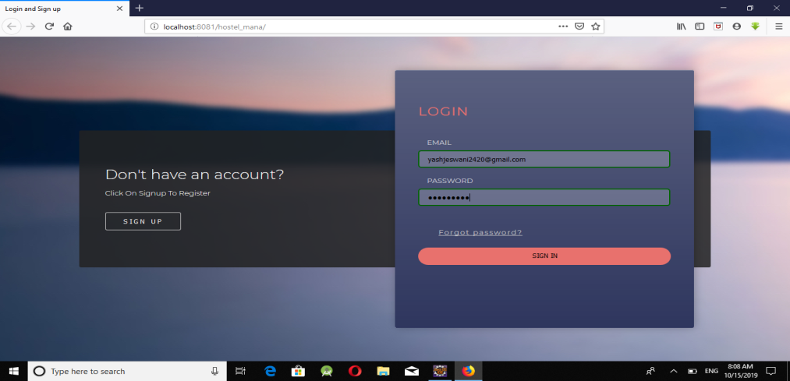](https://1.bp.blogspot.com/-e-SBCs3eF3A/WPXXYScMgoI/AAAAAAAAA4g/LFYRC8XTByACEdEYm84I5MoNINx1HNQpwCLcB/s1600/4.png)

[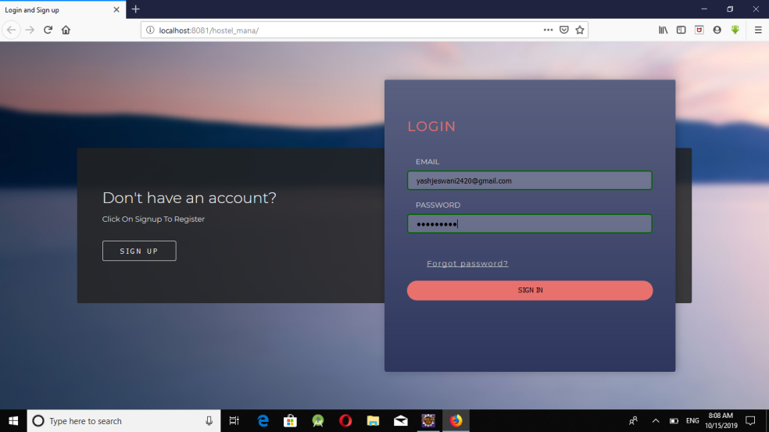](https://4.bp.blogspot.com/--2NFdz0RlIg/WPXXaSrr5cI/AAAAAAAAA4k/lqm9fFNKpfgMPKldV6wL9FzYO5pNgVIvwCLcB/s1600/5.png)

[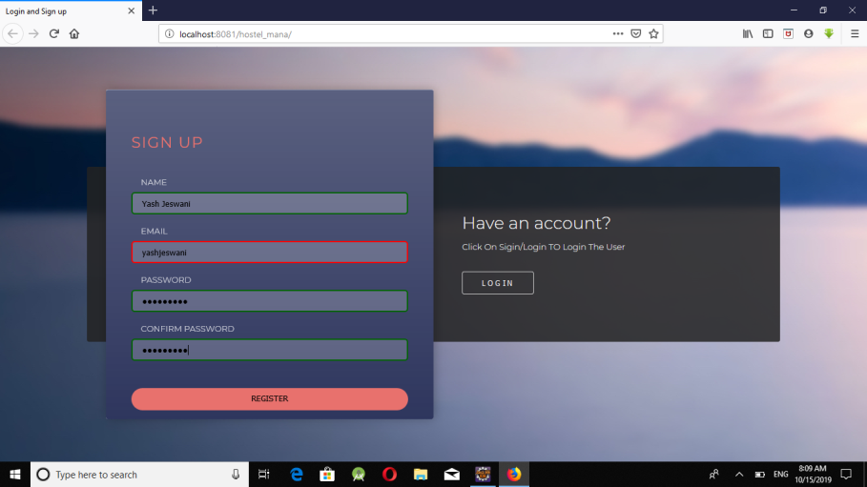](https://4.bp.blogspot.com/-uH2ljH1R4no/WPXXb780DBI/AAAAAAAAA4o/FzP3x06xJGkyil84naB_Nez4-KL6wM0NwCLcB/s1600/6.png)

[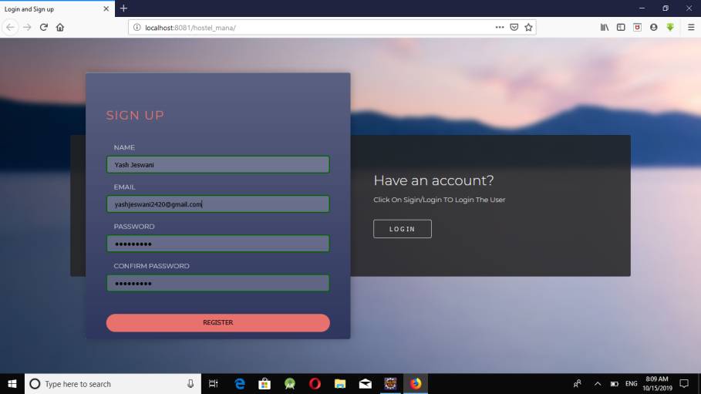](https://2.bp.blogspot.com/-Z0rIkeswv58/WPXXb0iOJeI/AAAAAAAAA4s/2qZ5ZpYQGz07t_3z9JF0Ebn_nlZv1ixuwCLcB/s1600/7.png)

[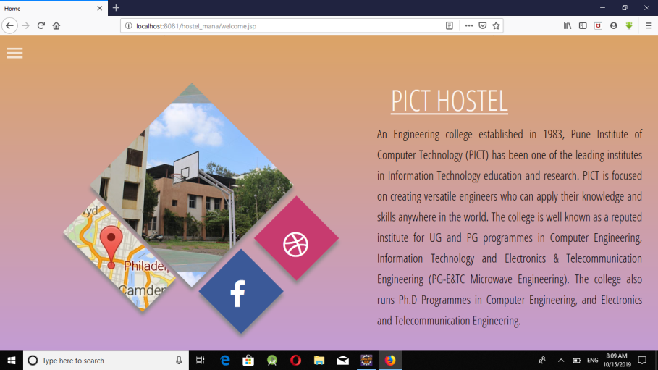](https://2.bp.blogspot.com/-Zs6TwDqesxA/WPXXc2Uk-CI/AAAAAAAAA4w/IsYCxRg5i5kv7xrrgFOlX9cxaJDBl222gCLcB/s1600/8.png)

[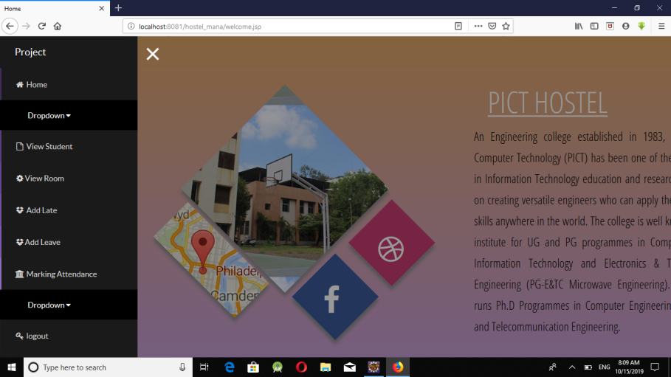](https://1.bp.blogspot.com/-ldONMea0GOA/WPXXeJ5fFJI/AAAAAAAAA40/Q6Pjj-ETKzkxm3I3uamyQ2L_cVzbWmjDQCLcB/s1600/9.png)

[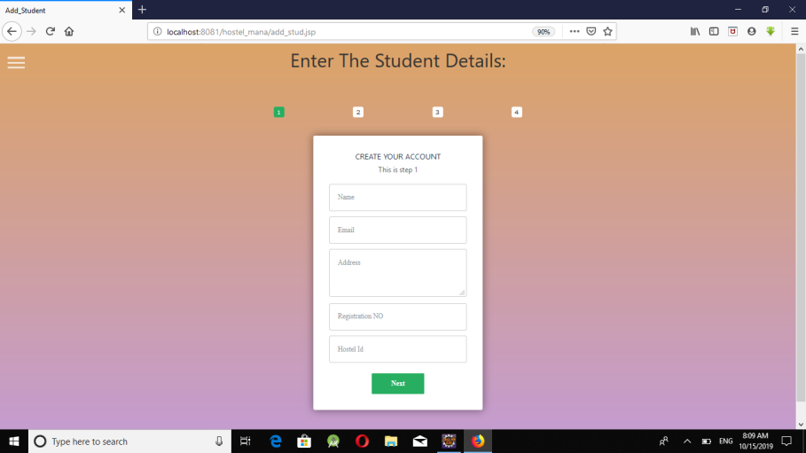](https://3.bp.blogspot.com/-eIYX5-i7zHM/WPXXVU6nTSI/AAAAAAAAA4E/BQL65xKrr0AnDt77uGCEsNdUxe1xgS-5gCLcB/s1600/10.png)

[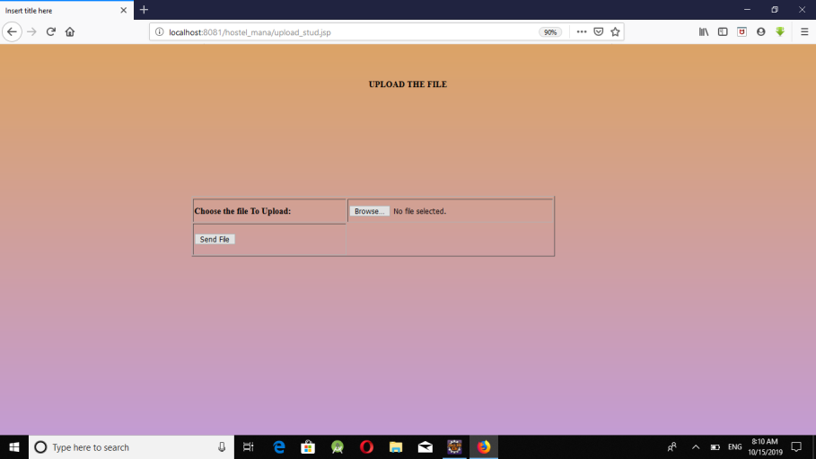](https://3.bp.blogspot.com/-eIYX5-i7zHM/WPXXVU6nTSI/AAAAAAAAA4E/BQL65xKrr0AnDt77uGCEsNdUxe1xgS-5gCLcB/s1600/10.png)

[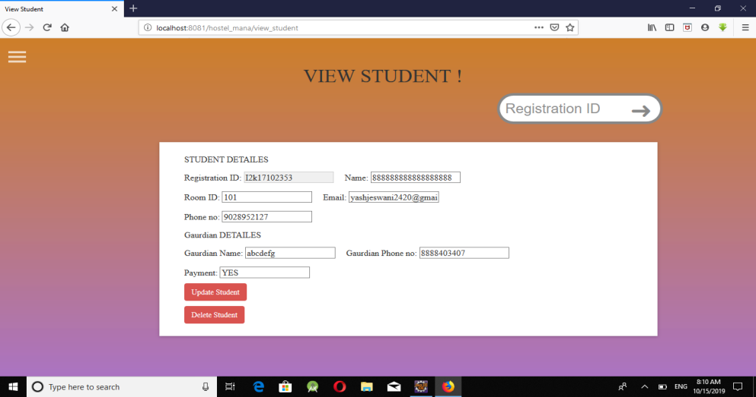](https://3.bp.blogspot.com/-eIYX5-i7zHM/WPXXVU6nTSI/AAAAAAAAA4E/BQL65xKrr0AnDt77uGCEsNdUxe1xgS-5gCLcB/s1600/10.png)

[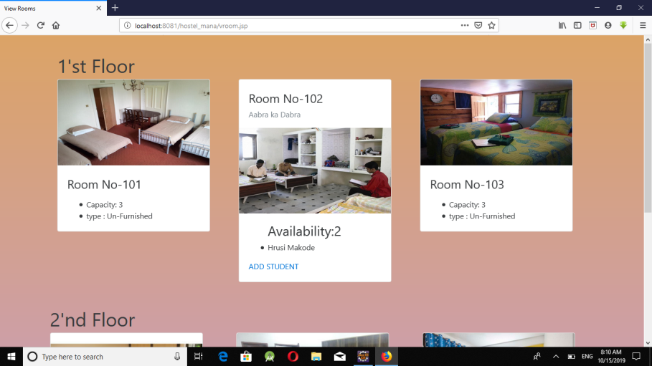](https://3.bp.blogspot.com/-eIYX5-i7zHM/WPXXVU6nTSI/AAAAAAAAA4E/BQL65xKrr0AnDt77uGCEsNdUxe1xgS-5gCLcB/s1600/10.png)

[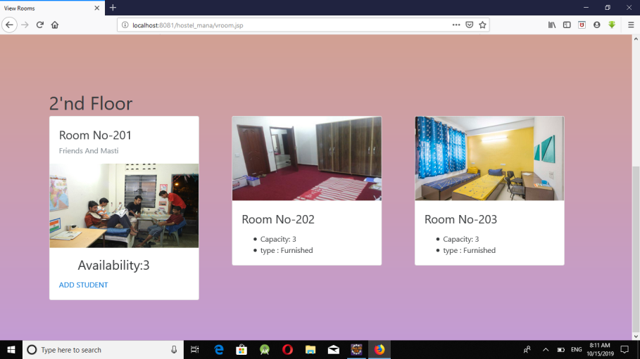](https://3.bp.blogspot.com/-eIYX5-i7zHM/WPXXVU6nTSI/AAAAAAAAA4E/BQL65xKrr0AnDt77uGCEsNdUxe1xgS-5gCLcB/s1600/10.png)

[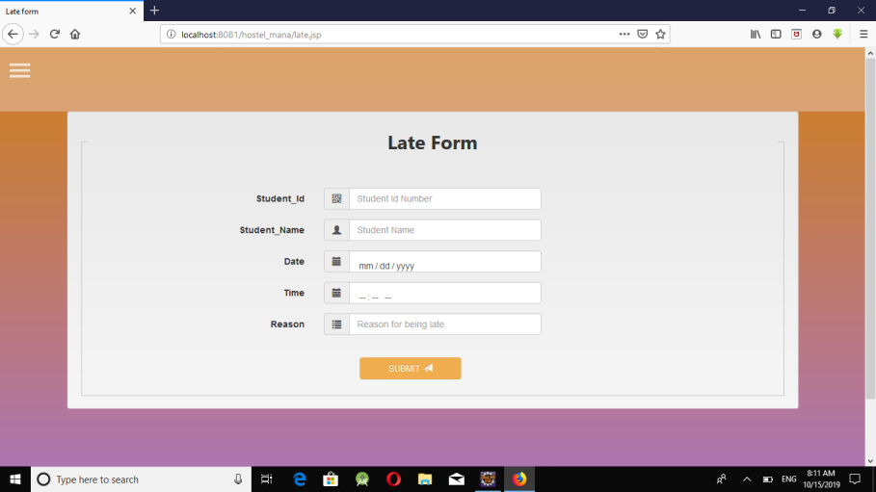](https://3.bp.blogspot.com/-eIYX5-i7zHM/WPXXVU6nTSI/AAAAAAAAA4E/BQL65xKrr0AnDt77uGCEsNdUxe1xgS-5gCLcB/s1600/10.png)

[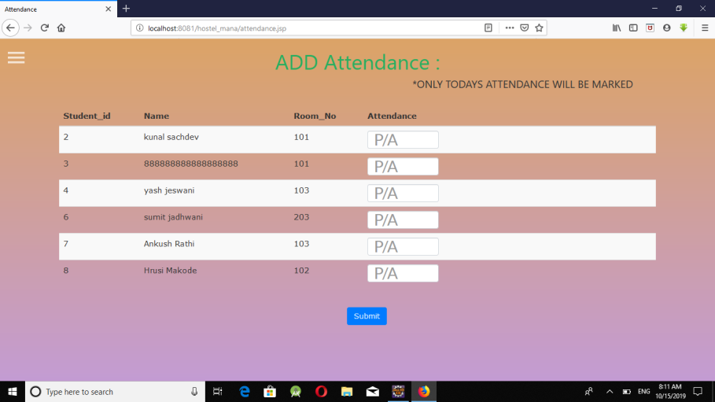](https://3.bp.blogspot.com/-eIYX5-i7zHM/WPXXVU6nTSI/AAAAAAAAA4E/BQL65xKrr0AnDt77uGCEsNdUxe1xgS-5gCLcB/s1600/10.png)

[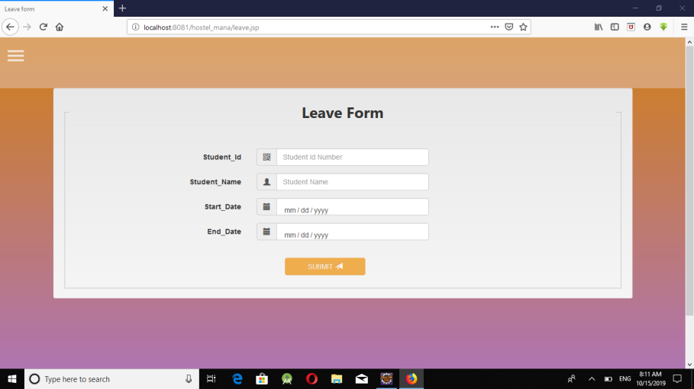](https://3.bp.blogspot.com/-eIYX5-i7zHM/WPXXVU6nTSI/AAAAAAAAA4E/BQL65xKrr0AnDt77uGCEsNdUxe1xgS-5gCLcB/s1600/10.png)

[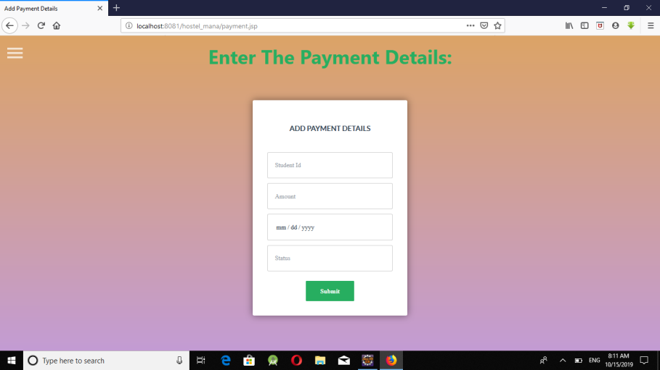](https://3.bp.blogspot.com/-eIYX5-i7zHM/WPXXVU6nTSI/AAAAAAAAA4E/BQL65xKrr0AnDt77uGCEsNdUxe1xgS-5gCLcB/s1600/10.png)

[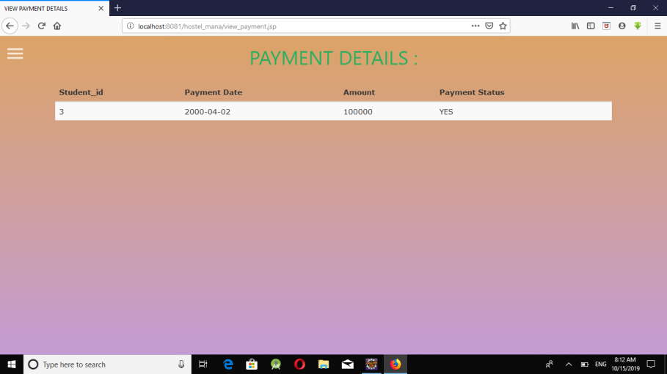](https://3.bp.blogspot.com/-eIYX5-i7zHM/WPXXVU6nTSI/AAAAAAAAA4E/BQL65xKrr0AnDt77uGCEsNdUxe1xgS-5gCLcB/s1600/10.png)

[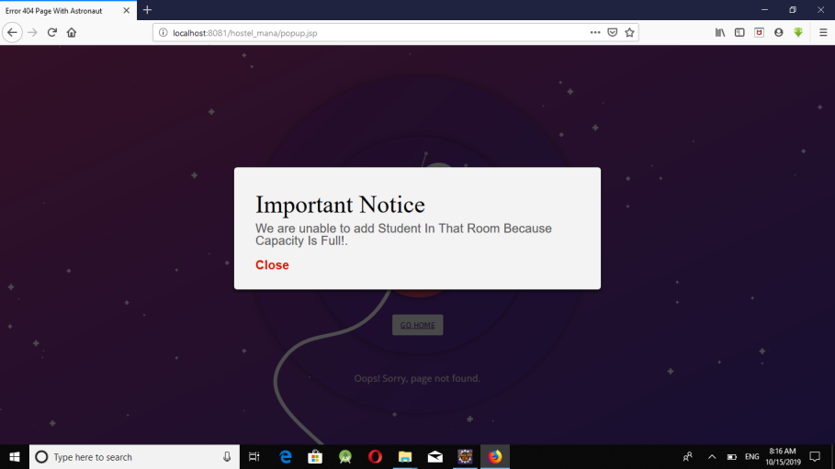](https://3.bp.blogspot.com/-eIYX5-i7zHM/WPXXVU6nTSI/AAAAAAAAA4E/BQL65xKrr0AnDt77uGCEsNdUxe1xgS-5gCLcB/s1600/10.png)

[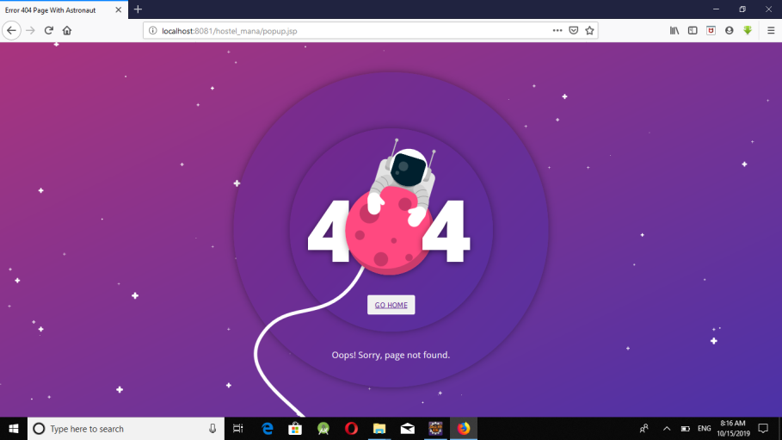](https://3.bp.blogspot.com/-eIYX5-i7zHM/WPXXVU6nTSI/AAAAAAAAA4E/BQL65xKrr0AnDt77uGCEsNdUxe1xgS-5gCLcB/s1600/10.png)

***STUDENT VIEW***:

[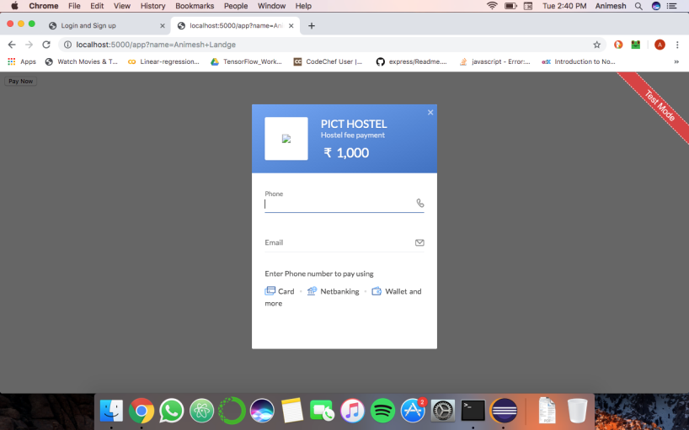](https://3.bp.blogspot.com/-3NGy4wuZOBA/WPXXVWAMf3I/AAAAAAAAA4I/v23TKoudDOQ9GjSHqNTcZQkER2nlh_togCLcB/s1600/11.png)

[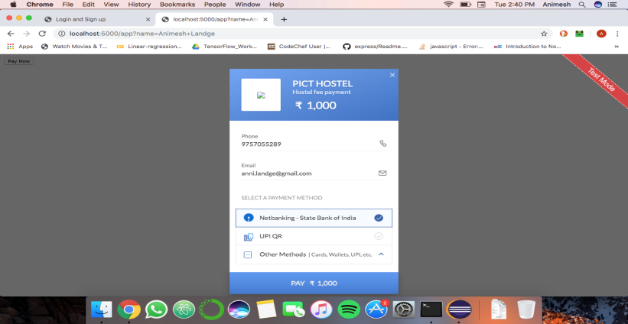](https://2.bp.blogspot.com/-KrvuduZ5_T0/WPXXVARy3VI/AAAAAAAAA4A/MJswWUDqJV0_90gFPzA6cWWjoQOrP-bpgCLcB/s1600/12.png)

[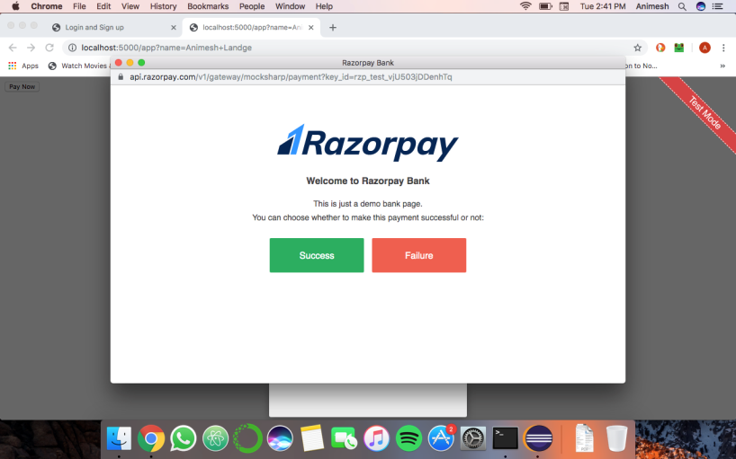](https://1.bp.blogspot.com/-0VvpapHqQ0Q/WPXXWcJQEFI/AAAAAAAAA4M/kydgnBXwWcIXhc8gKDJ4N4CuxA3DT-u9wCLcB/s1600/13.png)

[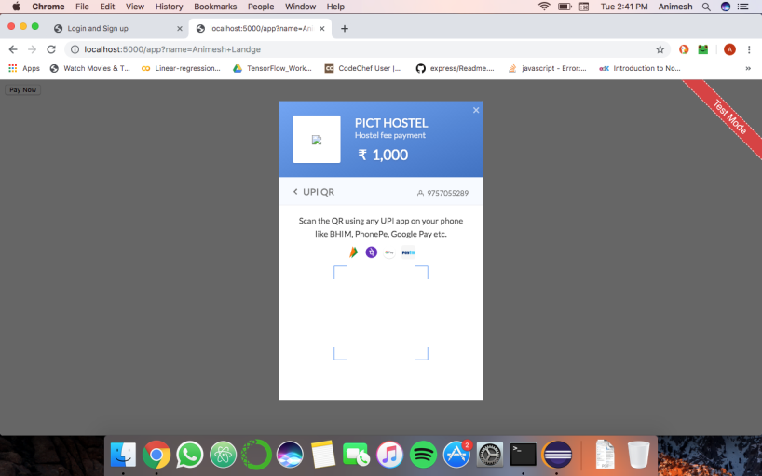](https://1.bp.blogspot.com/-ZupBx4Mh4B8/WPXXWsMEUBI/AAAAAAAAA4Q/7TB5SOZsHc47AkpBl_Rie-q3W4KAsm6AACLcB/s1600/14.png)

[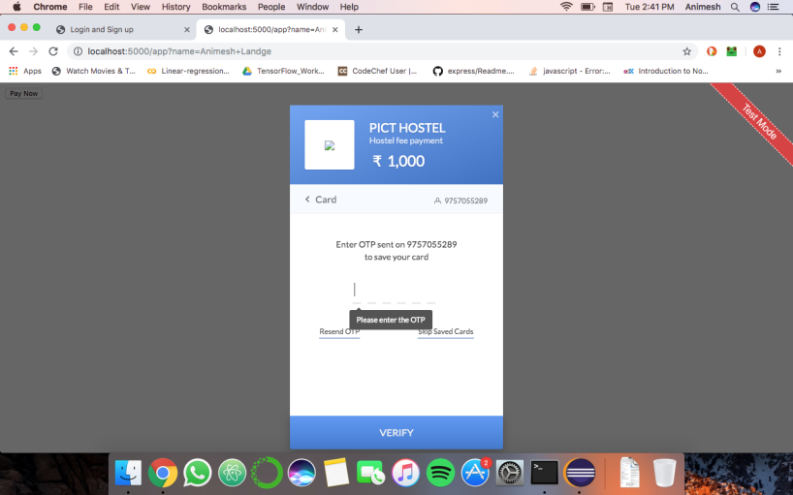](https://3.bp.blogspot.com/-ZZ_Z5LeF45M/WPXXWgKDSxI/AAAAAAAAA4U/8qRhfwn7s4sAwPjd_AyGzg9tFn46Jw86gCLcB/s1600/15.png)

[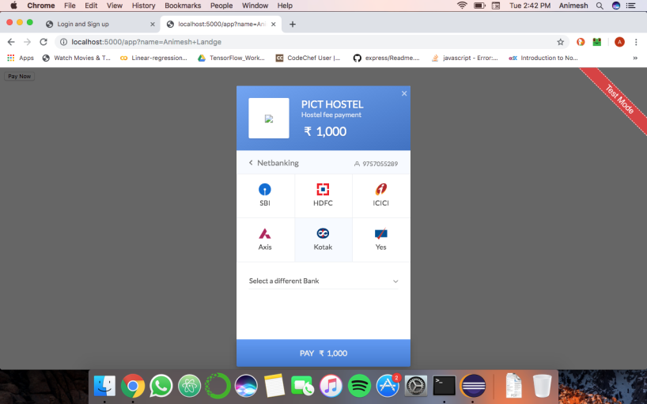](https://3.bp.blogspot.com/-eIYX5-i7zHM/WPXXVU6nTSI/AAAAAAAAA4E/BQL65xKrr0AnDt77uGCEsNdUxe1xgS-5gCLcB/s1600/10.png)

**CONCEPTS USED**

1.MySQL -(DATABASE BACKEND)

2.JSP -(FRONT END)

3.JDBC/ODBC -(CONNECTIVITY)

4. Triggers/PROCEDURES/etc

**SOFTWARE USED**

1. BROWSER

2. CHROME

3. ECLIPSE JEE

**13) *CONCLUSION*:**

Thus we have successfully implemented college hostel management system which helps warden in centralizing the data used for managing the students records living in a college hostel.

We have successfully implemented various functionalities of mysql and jsp and created the fully functional database management system for college hostel.

**14)*REFERENCES:***

* Head First Servlets and Jsp book
* Stackoverflow.com
* Javapoint.com
* Tutorialspoint